Traditions in Kanepi Gymnasium
Our school has many traditions, like singing and dancing classes. Our school takes part in Sing and Dance Festival and we have song competions at school. Every September our school celebrates the Health week, so we have Sports day and Country and Nature game for the whole school. Every class competes in the cross-country running. The next is Teachers’ Day where senior students can be teachers for one day. And in October every student of the 10th grade has to go through challenges, to become a fully-fledged gymnasium student.Also every class organizes an event in one month. Every month every class has to answer a media quiz which is about the most important things which happened during that month.
We also celebrate Christmas, Estonian Independence Day, Valentine's Day, Mother Language Day, Fathers’ Day and Mothers’ Day when we have a concert for the mothers. Every Feburary we have Shrove Tuesday(Vastlapäev), which is an old tradition in Estonia. Students usually go sledging.
Every April Kanepi Gymnasium has School Leaving ceremony for 12th graders. They have to do challenges. And in June the same day is for 9th graders because they are to prepare for the end of the Basic School. In April there is the St Jonh’s relay running around the Lake Erastvere. It is usually at night.
Strongman is the event where students can compete who is the strongest. The fun events are Playback where students cover the famous bands and singers, and Karaoke. In May, at the end of the school year the students who are excellent in sport, in studies, in after school activites etc, are invited to the Headmaster. The Headmaster will thank them. At the end of every period we have a little public ceremony.
Sports Day
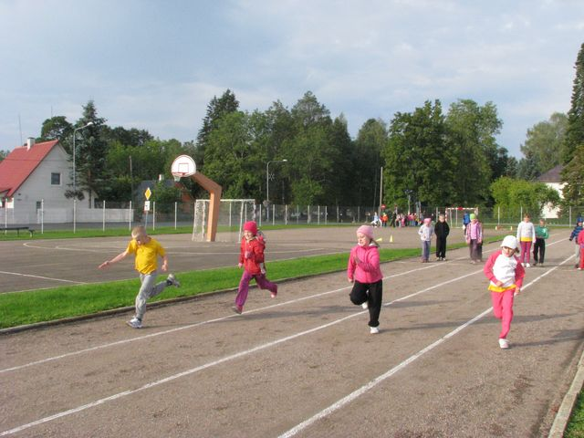
Country and Nature Game
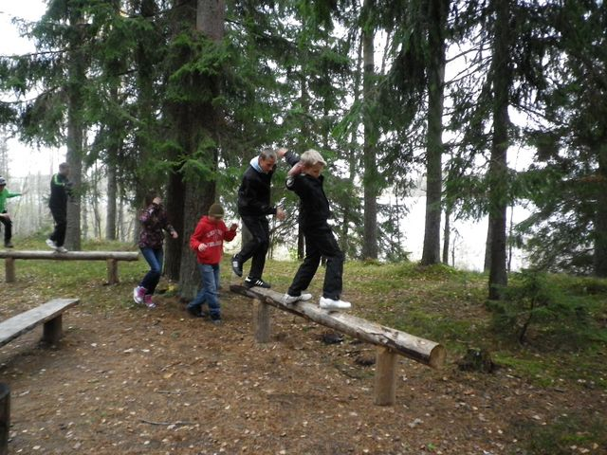

Shrove Tuesday
