The main directions of development of school
Vision
By to 2013 Kanepi Gymnasium is working for faithful student - centred learning atmosphere according to the principles of the quality leadership of the school.
Mission
- Kanepi Gymnasium helps students to develop young people who can cope with life.
- Kanepi Gymnasium provides opportunities for students to find a suitable hobby and develop young people, who would be able to do something with their spare time, who enjoy the art, culture, who actively participate in the cultural societies and associations.
- Kanepi Gymnasium creates assumptions for lifelong learning and coping in the academic society.
- Kanepi Gymnasium strengthens the historical and cultural ties of the students with domicile environment.
Mission implementation priorities
- The implementation of the new curriculum supports students' individual needs (gaining competences)
- Themes through curriculum (business, environment, environment, local environment, business language, research papers and media, information technology use) are integrated into the syllabuses. Students can treat information critically.
- After school activities support curriculum
- Activation of the School Student Councils' activities:
- The complementing of knowledge and skills of the SCE members' (training, briefings, etc.) to increase the SCE members’ intensity and sustainability in school.
- Cooperation development between SCE, students, teachers and the school management.
- Promote the healthy lifestyles ( the main attention is paid to the health movement events, because we are Health promoting School )
- The transmission of history and culture of Kanepi Parish for the future generation.

Objectives/Goals/Aims
      - Leadership and management
- Maintain Gymnasium
- To form a cooperation team
- Personnel/staff
- Motivated personnel/staff
- Decisions have been considered and implemented
- Resource
- Budget using is economic and legitimate
- Existing IT level of maintenance
- Stakeholders
- Parents who are informed and support school
- Active School Student Councils
- Important stakeholders are involved in school activity
- Teaching and learning
- Students behaviour and acting according to their abilities
- Systematic work with talented students
- Entrepreneurship is the part of the school curriculum
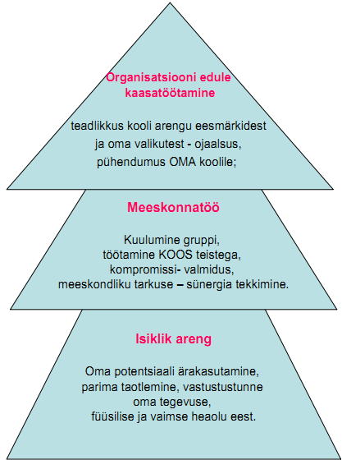
The Pyramid of Values: personal development, teamwork and organizational success. Based by the values of the new school type created by Jh. Ph. von Roth in the 19th century.

