Health promoting school
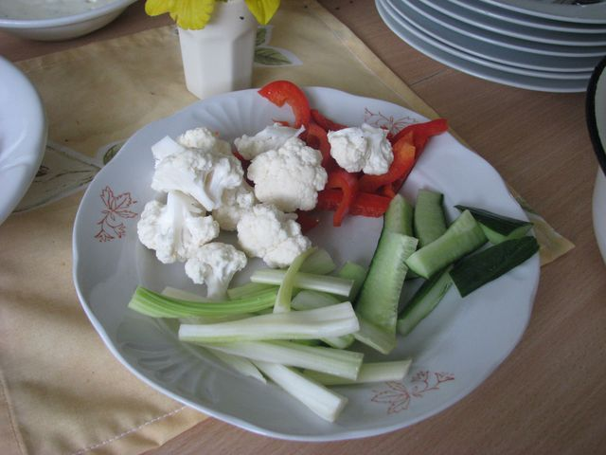
The name of the Health Promoting school was accepted in our school on 23th March 2001.
In recent years the health has been very important for our school. The events that are bound to health are planned in our event-calendar. Also there are some trainings conferences, summer schoolings and more. Of course, the most important activity is sport.
Events we had from September to October 2012:
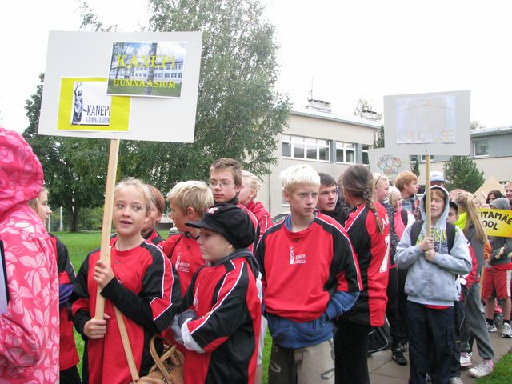
- The whole school Sports Day “Reipalt koolipinki” and the World Heart Day-11 September.
- 14th September forms 5 to 9 (a 10-membered team) took part in Olympic Games in Tilsi Basic School. This event is meant to be for schools who promote health in their schools. Very good experience for students was Fire Fighting Olympic- new and interesting.
- In October there was a traditional cross-country race (forms 1 to 12).
- Provincial sport competitions- football forms 6 to 9 and 10 to 12., cross- country relay forms 1 to 12, EKSL Rahvaliiga final in Ahtme (forms 10 to 12).
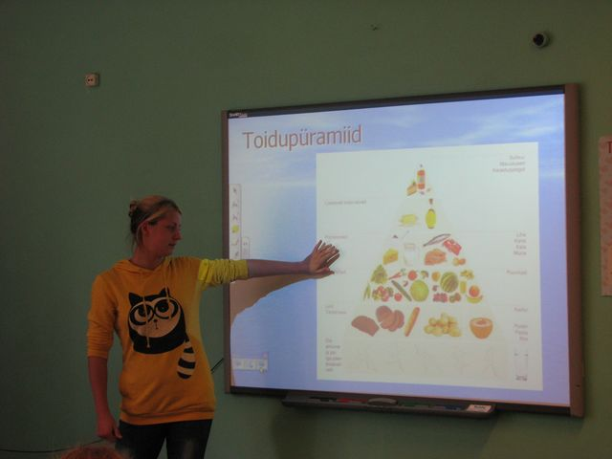
- We praise student council for organizing the health week in October 8 to 12. The aim of the health week was to advocate healthier lifestyle. That is why the student council organized for forms 1 to 6 a presentation about healthier foods and lifestyle. After the presentation the students drew pictures of healthier foods. The presentation was carried out by the members of student council- Maarja Lattik, Helena Kukk (form 11) and Helene Leht (form 12).
Forms 7 to 12 students composed some amateur-video clips about the healthy lifestyle. The themes were “Smoking is damaging health”(form 7), “I will be healthy and strong when I train”(form 8), “Drugs are damaging health”(form 9), “Vegetarian food and the need for it”(form 10), “Alcohol is damaging health”(form 11), “Why junk food”(form 12). At the end of the week there were some vegetables on the lunch table.
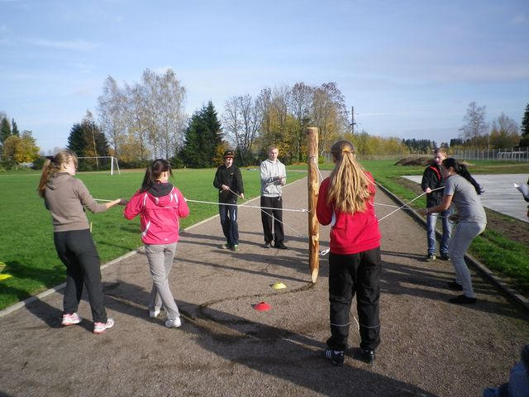
Active students of the week were prized on the 19th October. The Health Council of Põlva county backed up this attempt.
- There was a traditional whole school Nature Game on 18th October 2012
- Form 6 attended the whole country competition “non-smoking class” 8th October 2012 - 8th April 2013.
The strengths of Kanepi Gymnasium:
- The school offers students physical activeness
- ... good and delicious food
- ... information about the health behaviour.

